|  |  |
| --- | --- |
|  | **CALL US** [+27 83 278 7699](tel:+27832787699) **WEBSITE** [www.kmmqs.co.za](http://www.kmmqs.co.za)  **ADDRESS** Bryanston, Johannesburg **EMAIL** [info@KMMQS.co.za](mailto:info@kmmqs.co.za) |

15/11/2021

Human Resource,

CEDA,

Gaborone,

Dear sir/madam

**RE: REFERENCE FOR SIMISANI NDABA FOR PRODUCT DEVELOPMENT SPECIALIST**

I worked with Simisani Ndaba in my capacity as a Business Analyst at the Gauteng Department of Education. She was working full time as a Junior Business Analyst where she performed duties of a Business Analyst under my supervision as well as a SAS Strategy Management (StM) developer. We were involved in a fixed term project from 2012 uNtil the end of its term at the end of June 2013.

Simisani is an intelligent and motivated individual. She is quite capable and on various occasions she was able to stand in for the Senior Business Analyst. She could be relied on to provide accurate and reliable information to the development team with regards to business requirements.

As part of her responsibilities Simisani interfaced with senior level project stakeholders, gathering and documenting business requirements, conducting user acceptance testing (UAT), facilitating workshops for system hand-over and training users on newly developed applications. Simisani was also involved in the automation of Key Performance Indicators (KPls) as well as developing balanced scorecards and dashboards as pan of her duties as an StM developer.

lf you would like additional information about Simisani, you can email me at [mfmdima@gmail.com](mailto:mfmdima@gmail.com), 0027614442478.

Sincerely,

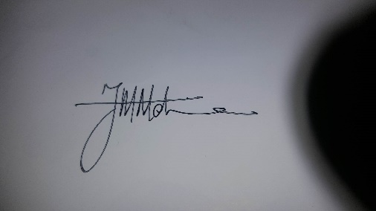

Mpumelelo Mdima

Business Process Analyst